**Unit 4: Triangle Relationships Quiz**

*25 points*

**Word Bank:**

Triangle Inequality Theorem altitude median

midsegment orthocenter centroid

1. *(2 points)* List the angles of ∆*ABC* from smallest to largest. Full credit will only be awarded if a diagram is drawn. *AB* = 20, *BC* = 12, *CA* = 10
2. *(2 points)* List the sides of ∆*ABC* from shortest to longest. Full credit will only be awarded if a diagram is drawn. *m*∠*A* = 100, *m*∠*B* = 20, *m*∠*C* = 60
3. *(1 point)* If two sides of a triangle are 1 and 3, the third side may be  
   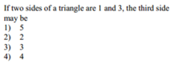
4. *(2 points)* If two sides of a triangle are 6 and 9, what is the range of possibilities for the third side, *x*?

1. 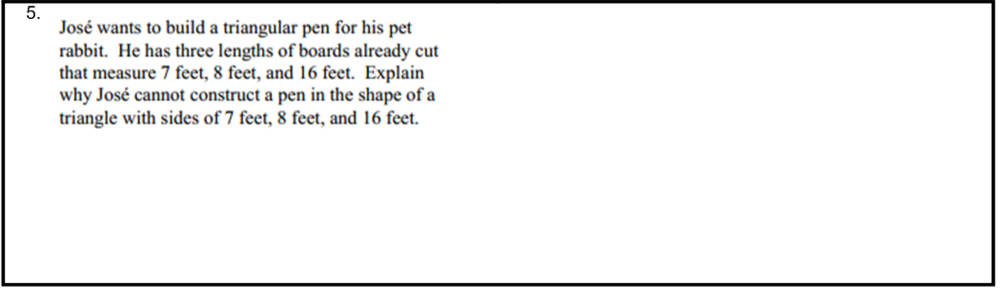 *(2 points)*  
   ________________________________________________________________________________________________  
   ________________________________________________________________________________________________  
   ________________________________________________________________________________________________  
   ________________________________________________________________________________________________  
   ________________________________________________________________________________________________
2. *(1 point)*  
   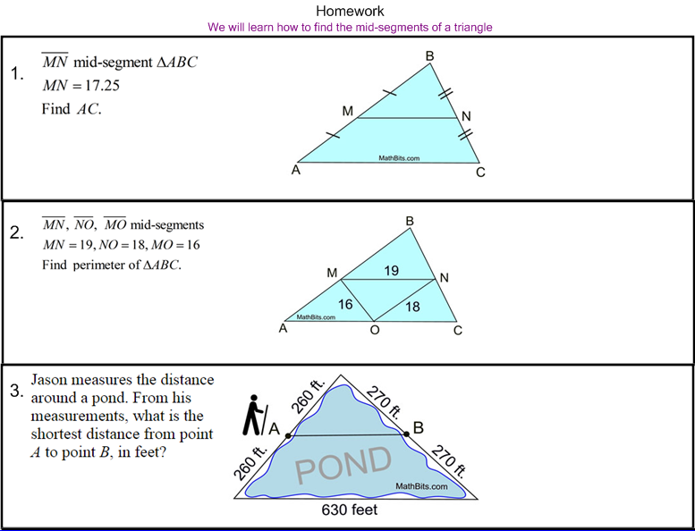
3. *(2 points)* Solve for x.   
   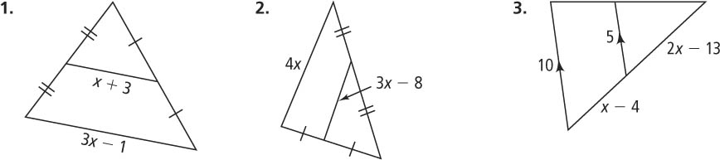

10. *(2 points)*

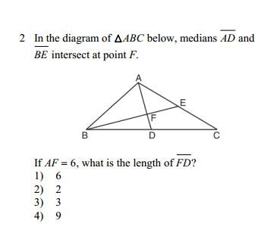

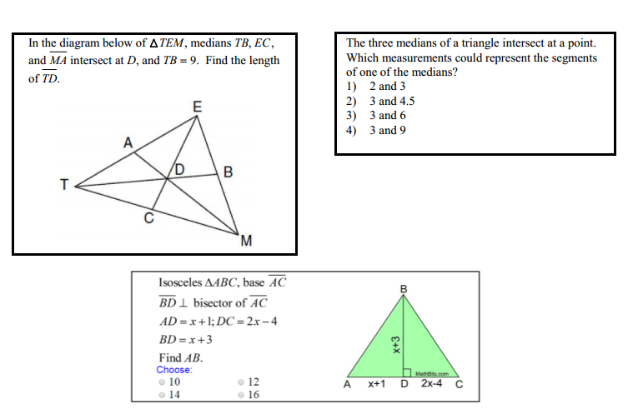11. *(2 points)*

12. *(3 points)*

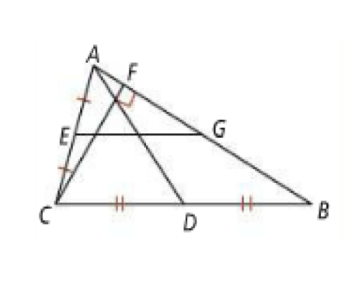Name the midsegment in the diagram

Name the median in the diagram

Name the altitude in the diagram

13. *(2 points)* Find the coordinates of the orthocenter of the triangle below.

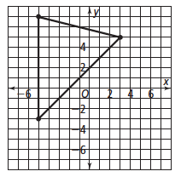

14. *(4 points)* ∆*ABC* has vertices at *A*(1, 4), *B*(−3, 4), and *C*(1, 1). Graph the triangle and find the coordinates of the centroid of ∆*ABC.*

